It’s time for our Annual
Weber County
Thanksgiving Turkey Drive!
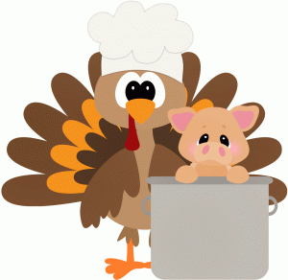
With the impact Covid-19 has had on so many families in Weber County, this year’s drive is especially important.
To help make a difference, please bring your donations of turkeys, hams and all other food items to the Commission Office by November 19th @ 10:00 a.m.

The Department that donates the most will win a Pizza Party!

